Tree Data Structure – Complete Notes

🔹 What is a Tree?
A Tree is a non-linear data structure used to represent hierarchical relationships.
👉 Unlike linear structures (Array, Linked List, Stack, Queue), a tree does not store elements sequentially.
✔️ Key Idea:
- Data is stored in nodes
- Nodes are connected via edges
- There is a parent-child relationship

🔹 Linear vs Non-Linear Data Structure
Type | Examples
Linear | Array, Linked List, Stack, Queue
Non-Linear | Tree, Graph

🌳 Basic Tree Terminology

- Root Node → Topmost node of the tree (starting point), e.g., node 1
- Child Node → Nodes directly connected below a parent node
- Parent Node → A node that has one or more child nodes
- Sibling Nodes → Nodes that share the same parent
- Leaf Node → Node with no children (terminal node)
- Internal Node → Node having at least one child (non-leaf node)
- Ancestor Node → Any node present on the path from root to a given node
- Descendant Node → Any node present below a given node in the tree
- Level → Distance of a node from the root (root is level 0 or sometimes 1)
- Number of Edges → Total connections between nodes, for n nodes → edges = n - 1
- Height of Tree → Maximum number of edges from root to the deepest leaf node (level - 1)
- Size of Tree → Total number of nodes present in the tree

🔹 Important Properties of Trees
- No loops (cycles)
- No self-loop
- Connected structure
- Traversal is done using:
  - DFS (Depth First Search)
  - BFS (Breadth First Search)

🔹 Tree Traversal
1. Depth First Search (DFS)
- Preorder → Root Left Right
- Inorder → Left Root Right
- Postorder → Left Right Root

2. Breadth First Search (BFS)
- Level Order Traversal

🌳 Types of Trees

🔸 1. Generic Tree
- Each node can have any number of children

🔸 2. Binary Tree
👉 Each node has at most 2 children
- Left child
- Right child

🔸 3. Binary Search Tree (BST)
👉 Special Binary Tree with property:
Left subtree < Root < Right subtree
- Helps in fast searching

🔸 4. AVL Tree
👉 Self-balancing BST
- Height difference ≤ 1
- Ensures O(log n) operations

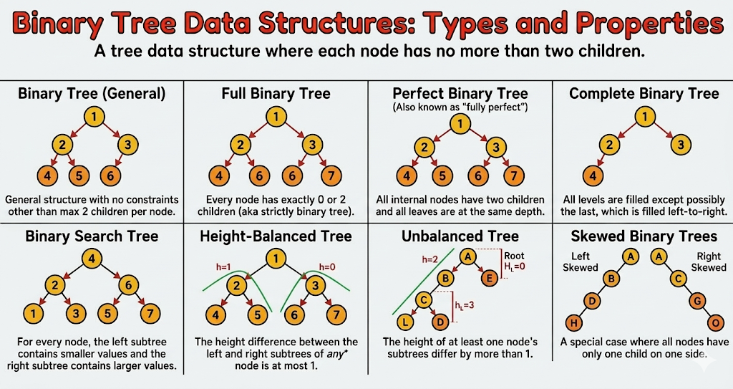

🔹 Applications of Trees
- 🌐 Hierarchical data (File systems, folders)
- 🔍 Searching (BST)
- 📊 Sorting (Tree sort)
- 🧠 AI / Decision Trees
- 🗄️ Databases (Indexing)
- 🌍 XML / HTML DOM

🔹 Binary Tree Key Point
👉 A Binary Tree node contains:
- Value
- Pointer to left child
- Pointer to right child

🧾 Summary
- Tree = Non-linear hierarchical structure
- No cycles, no loops
- Traversal → DFS & BFS
- Binary Tree → max 2 children
- Balanced trees → efficient operations
- Used in real-world systems (OS, DBMS, AI)

